SIMATS ENGINEERING (SAVEETHA SCHOOL OF ENGINEERING)
Department of Computer Science and Engineering
CO2 ASSESSMENT TOOL 2 – Architecture Design Assignment

Course Code: | CSA10 / CSA1063 | Course Title: | Software Engineering
CO Assessed: | CO2 | Assessment: | Assessment Tool 2 – Architecture Design Assignment
Weightage: | 20% | Total Marks: | 25
CO2 Statement: | Perform detailed requirements analysis, design scalable architectures, and prioritize features with a focus on cross-disciplinary skills
Student Name: | UKENTHAR.G | Reg. No.: | 192524022
Date: | 27/10/2026 | Duration: | 60 minutes

Code of Conduct
I __________________________ (Name / Reg No) certify that this submission is my original work and that I have adhered to the guidelines specified for this assessment. I understand that any violation of academic integrity rules will result in disciplinary action.
Signature of the Student: _________________________
Annexure A – Architecture Design Assignment
Instructions to Students:
Each student will be assigned an individual software project problem statement. Based on the assigned problem, analyze the system requirements and design an appropriate software architecture by applying software engineering principles. Your submission should demonstrate your ability to select, justify, and evaluate a suitable architectural style.

Question
Based on your assigned problem statement, perform an Architecture Design Analysis and prepare an architecture design report by answering the following questions:

1. Analyze System Requirements
- Study the given problem statement and identify the system objectives.
- Analyze the functional and non-functional requirements that influence the software architecture.
- Identify key quality attributes such as scalability, maintainability, reliability, availability, performance, and security.

2. Select a Suitable Software Architecture
- Select an appropriate architectural style for the proposed system (e.g., Layered Architecture, Client-Server, MVC, Microservices, Event-Driven, Service-Oriented Architecture, Serverless, or Hybrid Architecture).
- Justify why the selected architecture is the most suitable for the given problem.

3. Draw the Software Architecture Diagram
- Design a clear architecture diagram illustrating the overall structure of the proposed system.
- Include all major layers/components, databases, external systems, APIs, and communication mechanisms.
- Use appropriate software architecture notations and labels.

4. Explain Components and Their Interactions
- Describe the purpose and responsibilities of each architectural component.
- Explain how the components communicate and exchange data.
- Illustrate the overall workflow of the system.

5. Discuss Quality Attributes
Evaluate how the proposed architecture addresses the following aspects:
- Scalability
- Security
- Performance
- Reliability
- Maintainability
- Availability

6. Justify Architectural Decisions
- Explain the rationale behind your architectural choices.
- Discuss the trade-offs considered while selecting the architecture.
Explain how the chosen architecture supports future enhancements, system integration, and long-term maintainability.
ARCHITECTURE DESIGN ANALYSIS REPORT
Project Title: Student Attendance Management System
1. Analyze System Requirements
1.1 System Objectives
The Student Attendance Management System is designed to automate the process of recording, storing, monitoring, and managing student attendance in a college or university. The system replaces traditional paper-based attendance registers with a computerized application.
The main objectives are:
To record student attendance accurately.
To allow faculty members to mark and update attendance.
To calculate student attendance percentages automatically.
To enable students to view their attendance records.
To generate daily, monthly, and semester-wise attendance reports.
To protect attendance information from unauthorized access.
To reduce paperwork, processing time, and human errors.
1.2 Functional Requirements
The functional requirements describe the main operations performed by the system.
User Authentication: Allow authorized users to log in and log out.
Student Management: Add, update, view, and manage student details.
Faculty Management: Maintain faculty information and assigned courses.
Course Management: Manage course details and student enrollments.
Attendance Recording: Allow faculty members to mark students as present or absent.
Attendance Calculation: Calculate attendance percentages automatically.
Attendance Viewing: Allow students to view their own attendance details.
Report Generation: Generate attendance reports for different periods.
Low Attendance Identification: Identify students below the required attendance percentage.
Data Management: Store, retrieve, and back up attendance information.
1.3 Non-Functional Requirements
The non-functional requirements describe the quality and performance of the system.
Scalability: The system should support increasing numbers of students, faculty members, and attendance records.
Maintainability: The system should be divided into separate modules so that changes can be made easily.
Reliability: Attendance records must be stored accurately without duplication or loss.
Availability: The system should be accessible during normal college working hours.
Performance: Attendance records and reports should load quickly under normal operating conditions.
Security: The system must use authentication, role-based access, and secure password storage.
Usability: The user interface should be simple and easy to understand.
Data Integrity: The system should validate information before saving it to the database.
2. Select a Suitable Software Architecture
2.1 Selected Architecture: Three-Tier Layered Architecture
The proposed Student Attendance Management System uses a Three-Tier Layered Architecture. It consists of three main layers: the Presentation Layer, the Application or Business Logic Layer, and the Data Access Layer.
Each layer has a separate responsibility. The Presentation Layer interacts with users, the Business Logic Layer processes attendance-related operations, and the Data Access Layer communicates with the database.

2.2 Explanation of the Three Layers
1. Presentation Layer
This layer provides the user interface for administrators, faculty members, students, and college management. It contains login forms, dashboards, attendance forms, and report screens.
2. Application or Business Logic Layer
This layer processes requests from the user interface. It validates login credentials, checks user permissions, records attendance, calculates percentages, and prepares reports.
3. Data Access Layer
This layer manages communication between the application logic and the database. It performs database operations such as inserting, updating, retrieving, and deleting authorized records.
2.3 Justification for Selecting This Architecture
The Three-Tier Layered Architecture is suitable because the Student Attendance Management System contains different types of operations that can be separated into independent layers.
It separates the user interface from business logic and database operations.
It simplifies testing and debugging.
It improves security by controlling access to the database through the application layer.
It allows the user interface to be modified without changing the entire application.
It supports future expansion and easier maintenance.
It is suitable for a college-level system without the additional complexity of a microservices architecture.
Therefore, the Three-Tier Layered Architecture provides a simple, secure, maintainable, and scalable foundation for the proposed system.

3. Draw the Software Architecture Diagram
The following diagram shows the overall architecture of the Student Attendance Management System, including users, application layers, the database, and external services.
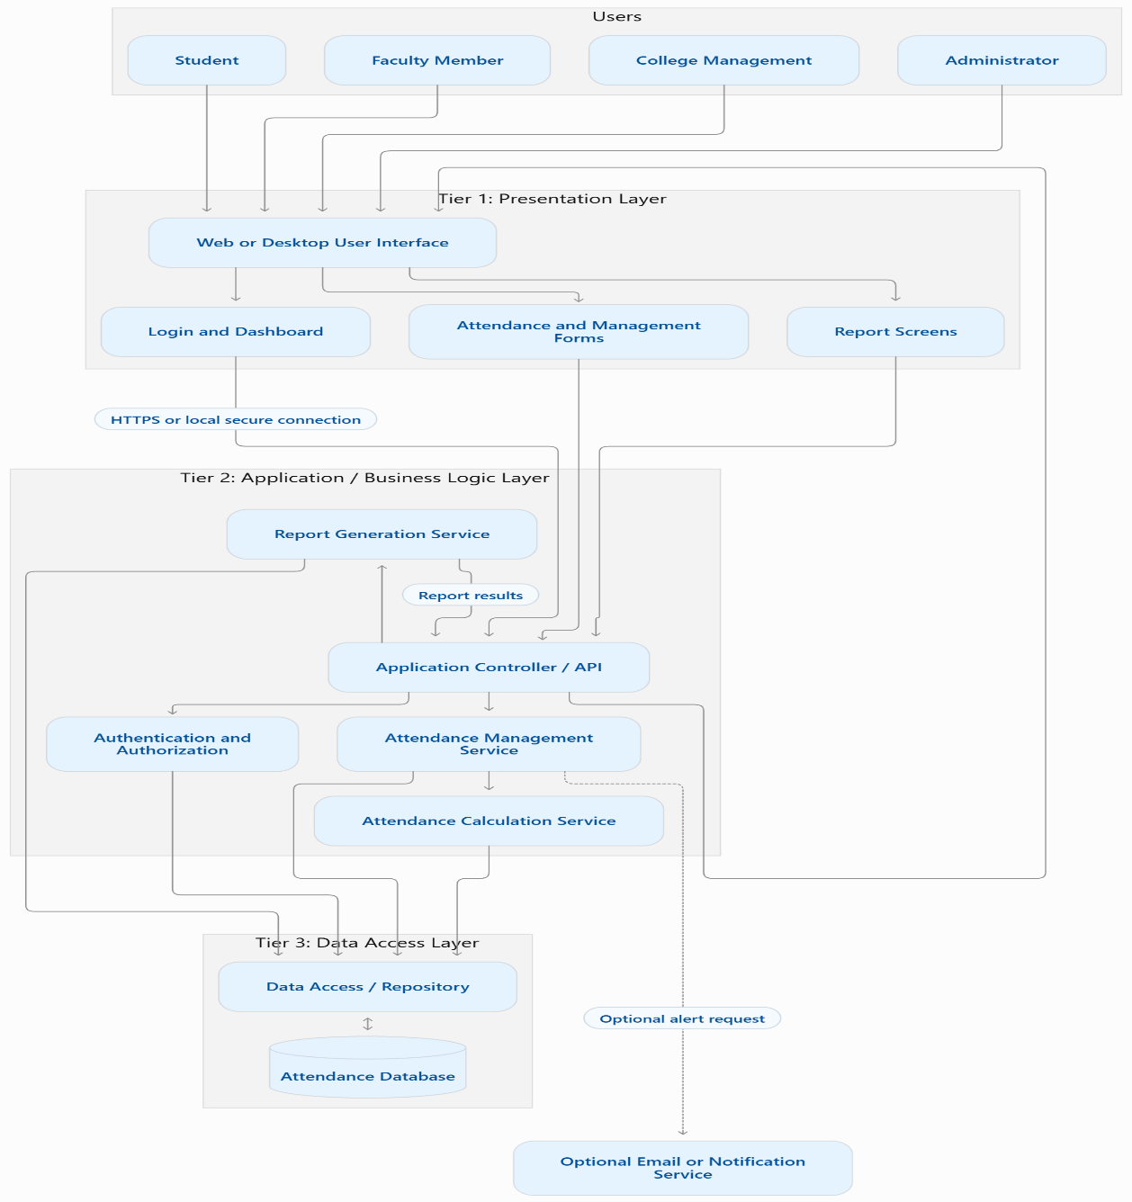
Diagram explanation: Users interact with the presentation layer. Requests are passed to the application layer, which validates permissions and performs the required operations. The data access layer communicates with the attendance database. Results are returned through the application layer to the user interface. An external notification service can be added if the college requires attendance alerts.

4. Explain Components and Their Interactions
4.1 Presentation Layer
The Presentation Layer is the front end of the system. It displays information and collects user input.
Its responsibilities include:
Displaying login screens and dashboards.
Providing forms for attendance recording.
Displaying student and faculty details.
Showing attendance percentages and reports.
Displaying validation messages and error notifications.
This layer sends user requests to the application layer and displays the returned results.
4.2 Application Controller or API
The Application Controller receives requests from the presentation layer and directs them to the appropriate service.
Its responsibilities include:
Receiving user requests.
Checking request data.
Directing requests to the correct business service.
Returning successful results or error messages.
Providing a consistent communication interface.
A web-based implementation may use REST APIs over HTTPS. A desktop application may communicate with local application services or a secured server API, depending on the deployment design.

4.3 Authentication and Authorization Component
This component verifies user identities and controls access to system functions.
Its responsibilities include:
Validating login credentials.
Identifying user roles.
Restricting access to unauthorized functions.
Ensuring students can view only their own attendance records.
Allowing faculty members to manage attendance for assigned classes.
4.4 Attendance Management Service
This component manages attendance-related operations.
Its responsibilities include:
Retrieving enrolled student lists.
Recording present and absent status.
Updating attendance when corrections are authorized.
Checking for duplicate attendance entries.
Validating attendance records before storage.

4.5 Attendance Calculation Service
This component calculates attendance percentages using stored records.
A simple formula is:
$$\text{Attendance Percentage}=\frac{\text{Classes Attended}}{\text{Total Classes Conducted}}×100$$
For example, if a student attends 36 out of 40 classes:
$$\frac{36}{40}×100=90\%$$
The calculated percentage is returned to the application layer for display and reporting.
4.6 Report Generation Service
This component generates attendance summaries and detailed reports.
Its responsibilities include:
Generating daily attendance reports.
Preparing monthly and semester-wise reports.
Identifying students with low attendance.
Filtering records by course, class, and date.
Providing report data for display, printing, or export.
4.7 Data Access Layer
The Data Access Layer acts as an intermediary between the business logic and the database.
Its responsibilities include:
Inserting attendance records.
Retrieving student and course information.
Updating authorized records.
Executing validated database queries.
Handling database errors.
Maintaining consistent access to stored information.
4.8 Attendance Database
The database stores all information required by the system.
Important data entities include:
Student details.
Faculty details.
User accounts and roles.
Course details.
Student enrollment information.
Attendance records.
Audit logs of attendance changes.
Primary keys and foreign keys maintain relationships between records. Constraints should prevent invalid and duplicate attendance entries.
4.9 External Notification Service
An optional email or notification service can send alerts to students when their attendance falls below the college's required percentage.
This component is not essential to the basic system. It can be integrated through an API if notification functionality is required.
4.10 Overall Workflow
The system follows these steps:
The user opens the application and enters login credentials.
The authentication component validates the credentials and permissions.
The user selects an operation, such as marking attendance or viewing a report.
The application controller forwards the request to the appropriate business service.
The business service validates the information and requests data operations from the Data Access Layer.
The Data Access Layer retrieves or updates information in the database.
The application processes the returned data and calculates attendance percentages when necessary.
The result is displayed to the user through the Presentation Layer.
If configured, the system sends a low-attendance notification through the external notification service.
5. Discuss Quality Attributes
5.1 Scalability
The layered design allows the system to be expanded as the number of students and attendance records increases. The application and database can be provided with additional processing capacity when needed. For larger deployments, caching, database indexing, and multiple application instances can be introduced.
5.2 Security
Security is maintained through authentication, role-based authorization, input validation, and secure database access. Passwords should be stored using an appropriate password-hashing algorithm rather than plain text. HTTPS should be used for network communication, and sensitive operations should be recorded in audit logs.
5.3 Performance
The application separates business logic from presentation and database operations, making performance improvements easier to implement. Database indexing, optimized queries, pagination, and efficient report generation can reduce response times.
5.4 Reliability
The system validates attendance information before saving it and uses database constraints to prevent duplicate records. Transactions help ensure that related changes are completed consistently. Regular backups and tested recovery procedures reduce the risk of permanent data loss.
5.5 Maintainability
The architecture separates user interface code, business rules, and database access. Developers can update the report generation service without redesigning the entire application. Individual layers can be tested and maintained independently, provided that their interfaces remain consistent.

5.6 Availability
The system should be available during college working hours. For a server-based deployment, availability can be improved through server monitoring, automated backups, recovery procedures, and redundant hosting where the budget permits. A basic single-server deployment may still experience downtime if that server fails.
6. Justify Architectural Decisions
6.1 Rationale Behind the Architecture
The Three-Tier Layered Architecture was selected because it provides a clear separation of responsibilities. The presentation layer manages user interaction, the application layer handles business rules, and the data access layer manages database operations.
This structure is appropriate for the Student Attendance Management System because the application requires frequent attendance updates, percentage calculations, report generation, and controlled access to student information.
It is also easier to develop and understand than a complex distributed architecture, making it suitable for an academic project.
6.2 Architectural Trade-Offs
Advantages | Limitations
Simple to understand and implement. | The application may become difficult to scale if all services are tightly coupled.
Easy to test and maintain. | A failure in a shared application server can affect the whole system.
Clear separation of responsibilities. | Communication between layers adds some processing overhead.
Centralized database management. | The database may become a performance bottleneck as usage grows.
Lower initial development complexity and cost. | Independent deployment of individual services is limited compared with microservices.
These limitations can be managed through modular code, optimized database queries, monitoring, and infrastructure improvements when necessary.

6.3 Support for Future Enhancements
The architecture can support future enhancements without requiring a complete redesign.
Mobile Application: A mobile interface can be added using the same application APIs.
Biometric Attendance: A biometric or RFID component can be integrated to record attendance automatically.
Notifications: Email or messaging services can be added through external APIs.
Advanced Analytics: Additional reporting modules can analyze attendance trends.
Cloud Deployment: The application and database can be hosted on cloud infrastructure.
Integration: The system can exchange authorized data with college management or learning management systems through APIs.
6.4 Long-Term Maintainability
The architecture supports long-term maintenance because each layer has a defined responsibility. Developers can improve the user interface, change business rules, or optimize database access with limited impact on other layers.
Clear documentation, automated testing, database backups, version control, and consistent API definitions will further improve maintainability.
Conclusion
The proposed Student Attendance Management System uses a Three-Tier Layered Architecture consisting of the Presentation Layer, Application or Business Logic Layer, and Data Access Layer. This architecture provides a clear structure for user interaction, attendance processing, secure data management, and report generation. It addresses the major quality attributes of scalability, security, performance, reliability, maintainability, and availability while keeping development complexity manageable. The architecture also supports future integration with mobile applications, notification services, biometric devices, and cloud platforms. Therefore, the selected architecture is a suitable foundation for developing and maintaining a reliable Student Attendance Management System.

Rubrics for Calculation
Evaluation Criteria | Excellent (4 Marks) | Good (3 Marks) | Satisfactory (2 Marks) | Needs Improvement (1 Mark)
System Requirement Analysis (30%) | Thoroughly analyzes the problem statement, accurately identifies functional and non-functional requirements, and clearly explains quality attributes influencing the architecture. | Analyzes most requirements with minor omissions or limited explanation. | Identifies only basic requirements with partial analysis. | Requirement analysis is incomplete, inaccurate, or lacks clarity.
Selection of Software Architecture (25%) | Selects the most appropriate architectural style with strong technical justification aligned to system requirements. | Selects a suitable architecture with reasonable justification. | Architecture is partially suitable with limited justification. | Inappropriate architecture selected or justification is missing.
Architecture Diagram and Component Design (20%) | Produces a clear, complete, and well-structured architecture diagram with all major components, interfaces, and interactions accurately represented. | Diagram is mostly complete with minor omissions or notation issues. | Diagram includes only essential components and lacks sufficient detail. | Diagram is incomplete, unclear, or technically incorrect.
Component Interaction and Quality Attribute Analysis (15%) | Clearly explains component responsibilities, interactions, and thoroughly discusses scalability, security, performance, reliability, maintainability, and availability. | Explains most components and quality attributes with minor gaps. | Provides limited explanation of interactions and addresses only some quality attributes. | Component interactions and quality attributes are poorly explained or missing.
Architectural Justification and Technical Presentation (10%) | Provides strong justification for architectural decisions, discusses trade-offs and future enhancements, and presents a well-organized, professional report. | Provides adequate justification with minor gaps; report is well organized. | Limited justification with minimal discussion of trade-offs or future scope; report needs improvement. | Justification is weak or absent; report lacks organization and technical clarity.

Criteria | Mark
System Requirement Analysis (30%) | /5
Selection of Software Architecture (25%) | /5
Architecture Diagram and Component Design (20%) | /5
Component Interaction and Quality Attribute Analysis (15%) | /5
Architectural Justification and Technical Presentation (10%) | /5
TOTAL | /25

